Notification - Free miscellaneous iconsDashboard icon - Free download on IconfinderDocument Icon | Mono General 2 Iconset | Custom Icon DesignCash, coin, currency, finance, money, payment, peso icon - Download on  IconfinderPerson Svg Png Icon Free Download - Profile Icon White Transparent Clipart  (#1814767) - PinClipart**ONLINE REGISTRAR APPOINTMENT SYSTEM**

AFTER LOGIN (STUDENT’S ACCESS)

Profile

Notification

List of Request

Dashboard

Payment

Profile

****Person Svg Png Icon Free Download - Profile Icon White Transparent Clipart  (#1814767) - PinClipartCash, coin, currency, finance, money, payment, peso icon - Download on  IconfinderDocument Icon | Mono General 2 Iconset | Custom Icon DesignDashboard icon - Free download on IconfinderNotification - Free miscellaneous icons**ONLINE REGISTRAR APPOINTMENT SYSTEM**

**Received**

2

**Pending**

1

**Paid**

3

Dashboard

Profile

Payment

List of Request

Dashboard





File:Edit icon (the Noun Project 30184).svg - Wikimedia CommonsFile:Edit icon (the Noun Project 30184).svg - Wikimedia CommonsFile:Edit icon (the Noun Project 30184).svg - Wikimedia Commons****Person Svg Png Icon Free Download - Profile Icon White Transparent Clipart  (#1814767) - PinClipartCash, coin, currency, finance, money, payment, peso icon - Download on  IconfinderDocument Icon | Mono General 2 Iconset | Custom Icon DesignDashboard icon - Free download on IconfinderNotification - Free miscellaneous icons**ONLINE REGISTRAR APPOINTMENT SYSTEM**

+ Add Request

List of Request

Year

Edit/Delete

Sort by: Date Request

Ascending Type

Unique Number

Clickable

After Clicking it will go to Request Document Step-by-Step Process (The update of the Request Document)

**Request Information**

|  |  |  |  |  |  |  |  |  |  |  |
| --- | --- | --- | --- | --- | --- | --- | --- | --- | --- | --- |
| Control No. | Student ID | Course | Year Level | Document Name | No. of Copy | Date Request | Date Releasing | Processing Officer | Status | Action |
| 2022-1234 | 191C-00699 | BSIT | 1st Year | TOR | 1 | April 14, 2022 | April 15, 2022 | Wilbert Bonifacio | Pending |  |
| 2022-4567 | 191C-00648 | HRM | 2nd Year | Grades | 1 | April 16, 2022 | April 16, 2022 | Wilbert Bonifacio | Paid |  |
| 2022-1258 | 191C-12345 | Tourism | 3rd Year | Good Moral | 1 | April 20, 2022 | April 24, 2022 | Wilbert Bonifacio | Receive |  |

Dashboard

List of Request

Payment

Profile

AFTER LOGIN (STUDENT’S ACCESS)

Document Icon | Mono General 2 Iconset | Custom Icon DesignDocument Icon | Mono General 2 Iconset | Custom Icon DesignNotification - Free miscellaneous iconsDashboard icon - Free download on IconfinderDocument Icon | Mono General 2 Iconset | Custom Icon DesignCash, coin, currency, finance, money, payment, peso icon - Download on  IconfinderPerson Svg Png Icon Free Download - Profile Icon White Transparent Clipart  (#1814767) - PinClipart**ONLINE REGISTRAR APPOINTMENT SYSTEM**

SUBMIT

Date   
Request

Grade Level for   
 the Requested   
 Document

Document   
 Name

Student ID.

Control No.

Automatic (Unique no.)

Request Info

Add Request

Clickable Date and Time

Limited appointment (20person per hour)   
School Hours: 8am-5pm only  
 - Monday-Saturday   
 - During Saturday school hours are only   
 8am-12pm

(Drop Down)

* Evaluation
* Good Moral
* Diploma (1st Copy)
* Certificate of Enrollment
* Certificate of Grade
* Certificate of Graduation
* Certificate of GWA
* Transcript of Records(for employment)
* Form 137
* Verification of Education(HS)
* Certified True Copy
* Copy of Grades
* RLE
* CAV

List of Request

Dashboard

Payment

Profile

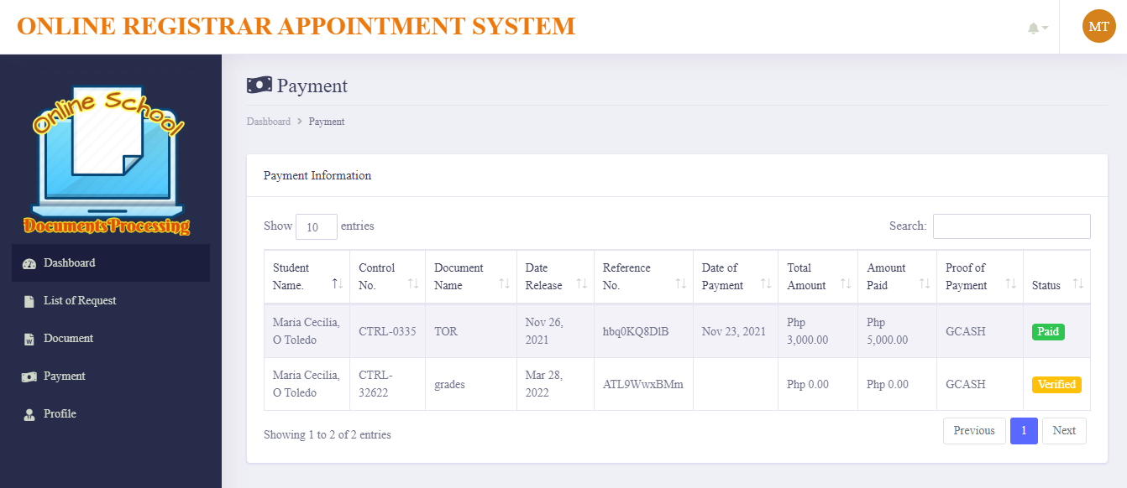

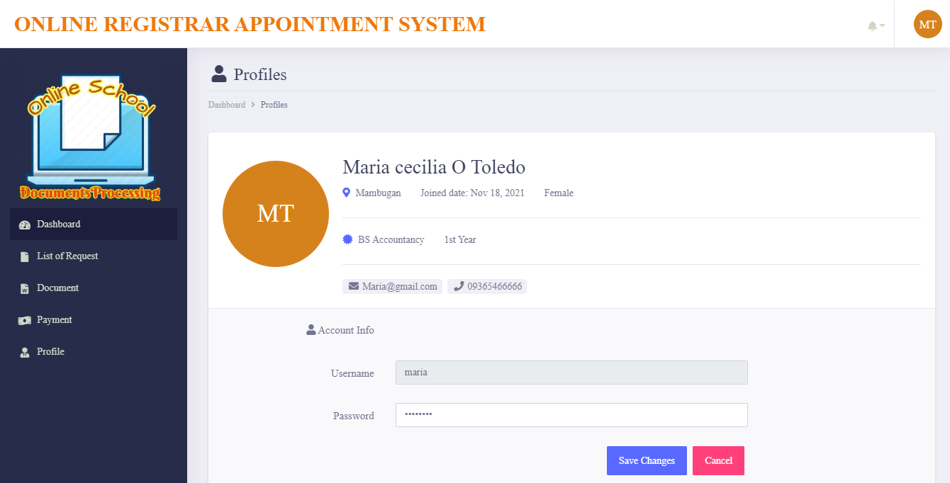



**LOGIN FORM**

Forgot Password

Continue

Middle

(Drop Down)

* BASIC EDUCATION DEPARTMENT
* SENIOR HIGH SCHOL DEPARTMENT
* COLLEGE DEPARTMENT
* GRADUATE SCHOOL DEPARTMENT

Year Level:

Password:

Student ID.:

STUDENT’S ACCESS